**TACTIC-E Trial**

**Are you interested in contributing to COVID-19 research?**

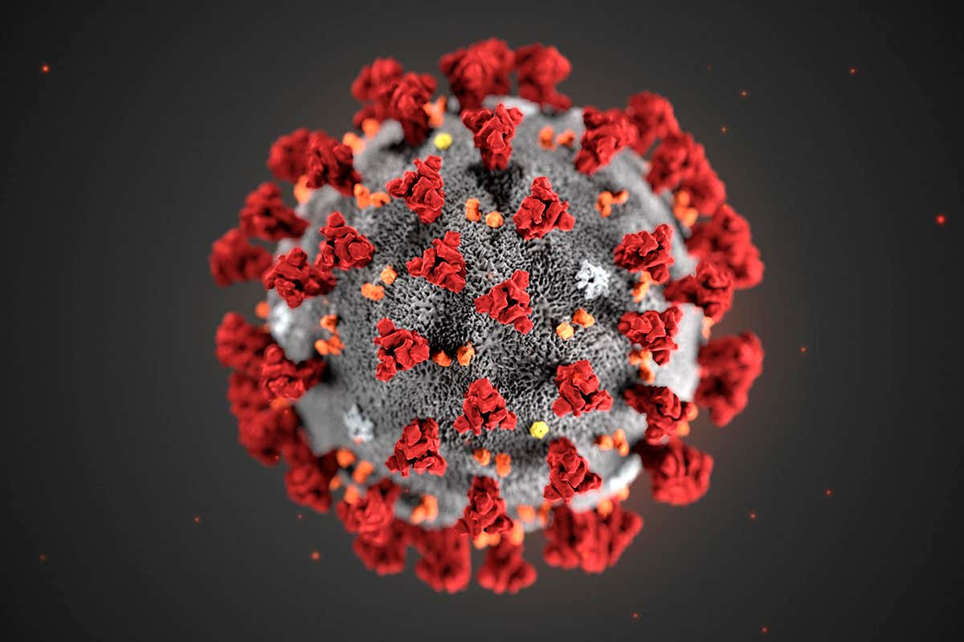

*Image from CDC/Science Photo Library dated 14 April 2020*

**We are recruiting adults admitted to the hospital with COVID-19 symptoms to participate in a clinical trial.**

**The trial will investigate the effects of different drugs (EDP1815, Dapagliflozin with Ambrisentan, and UNI911) on COVID-19 patients.**

If you think you may have a suitable patient and would like additional information, please contact our research team:

Dr Edward Banham-hall - Tel: +44 (0) 1223 348320/349009

Dr Joseph Cheriyan - Tel: +44 (0) 1223 256653

or a member of the TACTIC–E study team

on - Tel: +44 (0) 1223 586852

IRAS ID: 283769 TACTIC-E Poster v2.0 dated 3 March 2021